The term IoT was first mentioned with reference to a global extended system to RFID and other sensors.

Futher, the electronic product coat (EPC) was developed to spread use of RFID in world wide networks.

Gradual development of wireless communication system such as WIFI, Bluetooth, NFC, wireless sensors network (WSN) and cellular technologies do the evolution of IoT.

IoT system consists of set of smart devices or things that interact or a collaborate basis to fullfil a common goal.

Things collect data from environment, compute and integrate simulatenosly to world.

**RFID (Radio Frequency IDentification) -** interlligent barcodes, capable to talk to networked system to track objects.

**Wi-Fi** - local wireless networking technology, that is used in IoT devices or home automation.

Wi-Fi used 2.4 Ghz frequency band and 5 Ghz band for communication.

**NFC** - enables devices to share info wirelessly by putting them in touch or bringing them into proxymity with each other.

**M2M (Machine to Machine) -** used for remote monitoring. Key components of M2M includessensors, RFIDs, NFC, BlueTooth, Wi-Fi, cellular communication.

Sensor - device to convert a physical phenomenon into electrical signal.

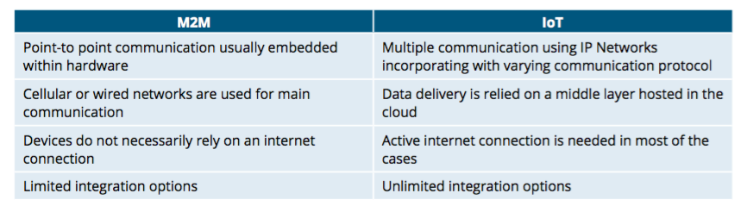

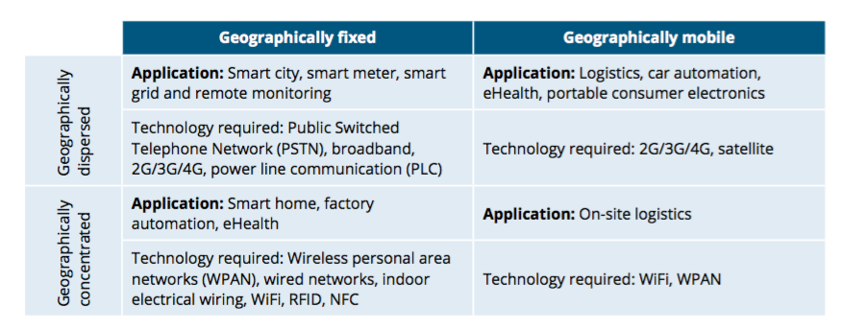

IoT app approach - alternative approach, where apps will no longer work in isolation, but will share infrastructure, environment and network elements.

IoT environment is driven by technologies, shown here:

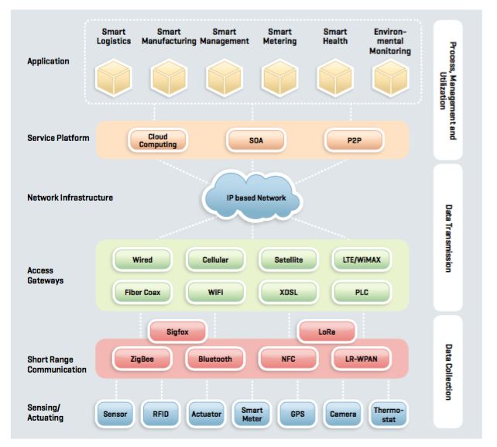

These technologies could be classified into three groups:

* Data Collection Phase
* Data Transmission Phase
* App Phase (including data processing, managing & utilization)

Collection Phase corresponds to procedure of sensor environment; collection real-time physical data. This information could be collected using sensors, RFIDs, actuators, cameras, GPS terminals and thermostates.

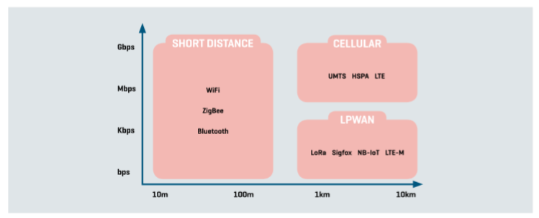

Data can be collected on short and long distances.

Short range:

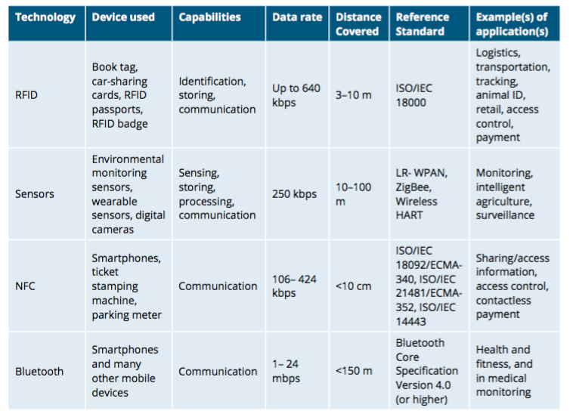

Long range:

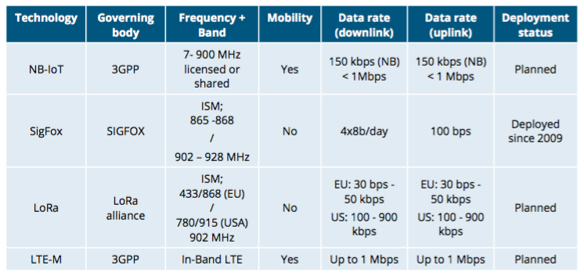

Data transmission phase - data is collected through sensing, needs to be transmitted to the service platform.

Transmission technologies:  
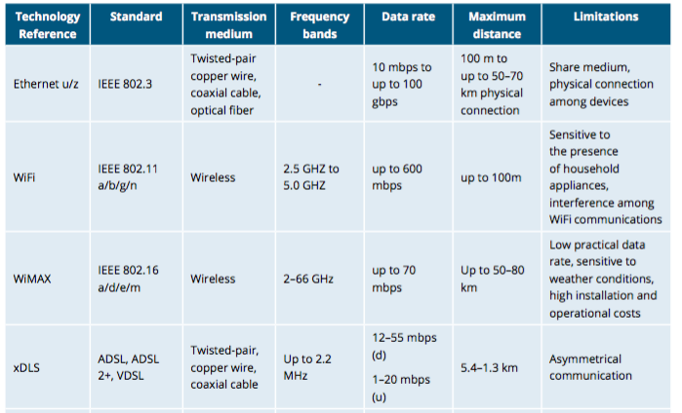

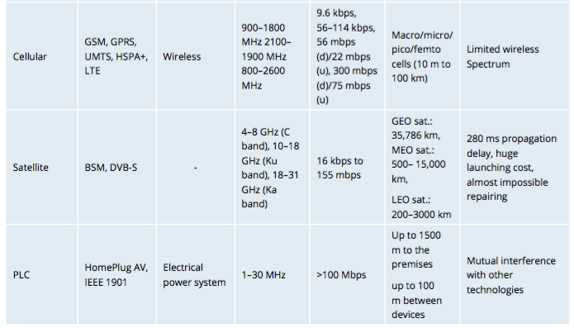

**App phase** - responsible for abstracting all the features of networks, services and objects.

The adoption of cloud computing supports a realization of delivery of hosted services over the Internet.

Despite of , there are still unsolved issues such as lack of mobilities support and location awareness. The cloud computing technology is more about providing distributed resources in the core network. Recent computing technologies such as Edge, Fog and Roof can address those problems by providing elastic resources and services to the end uses.

дома написать определения компутинг технологиес.